🏠 SMART · CONNECTED · AUTOMATED 🏠  PROJECT REPORT  🏡 Arduino Based Smart Home System  Integrated Automation and Security System using Arduino Uno  🖥️ Simulated and Designed in Tinker CAD  Prepared By  Mallampally Jayantha Siva Srinivas  B.Tech, Electronics & Communication Engineering | 🔧 PROJECT FEATURES  🔒 Door Locking System  Ultrasonic + Servo  🌡️ Fan Speed Control  LM35 Sensor  💡 Room Lighting Control  LDR Sensor  🚨 Motion Security Alert  PIR Sensor  🔥 Gas Detection  MQ2 Sensor  📟 LCD Display  16x2 I2C  🖥️ Serial Monitor  Debug Output

1. Abstract
This project presents the design and simulation of an Arduino Uno based Smart Home System that integrates multiple automation and security sub-systems into a single, unified platform. The system automates door locking and unlocking using an ultrasonic distance sensor and a servo motor, regulates fan speed automatically based on ambient temperature sensed through an LM35 temperature sensor, and controls room lighting automatically using a Light Dependent Resistor (LDR). In addition to automation, the system incorporates two safety and security features: a PIR motion sensor that monitors a secret locker door and raises an audible alert on detecting motion, and an MQ2 gas sensor that continuously monitors the surrounding air and raises a distinct audible alert if a gas leak is detected. All sensor readings and system statuses are displayed in real time on a 16x2 I2C LCD display as well as printed to the Serial Monitor for debugging and verification. The complete system was designed, wired, and simulated using Tinker CAD, and the results confirm reliable automated responses across all sub-systems.

2. Objectives
- To design an automatic door locking and unlocking mechanism using an ultrasonic sensor and servo motor.
- To implement automatic fan speed control based on real-time temperature readings using a DC motor.
- To design an automatic room lighting system that responds to ambient light levels using an LDR.
- To integrate a 16x2 I2C LCD for real-time visual display of all sensor readings and system status.
- To implement a PIR motion-based security alert system for a secret locker door.
- To implement a gas leak detection and alert system using an MQ2 gas sensor.
- To simulate and validate the complete integrated system using Tinker CAD.

3. Components Used
The following components were used in the design and simulation of the project:
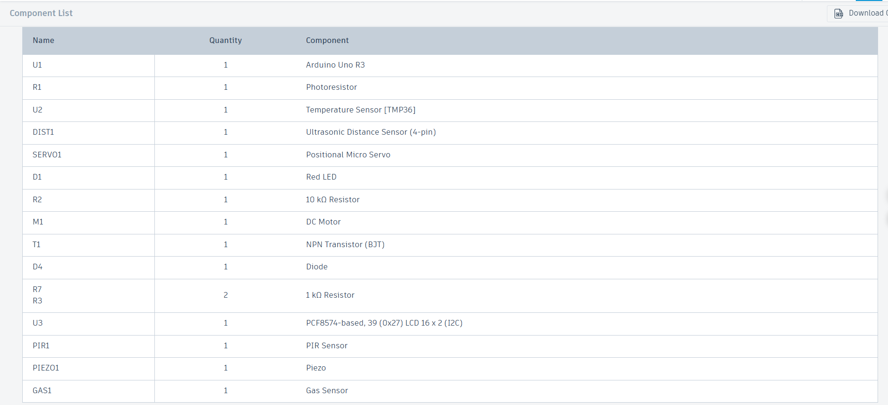
Fig 3.1: Component List (Tinker CAD)

4. Sensor Placement in the House
Each sensor in this system is positioned at a specific location within the house based on its intended function, as described below:
- Ultrasonic Distance Sensor (HC-SR04): Mounted at the main entrance door of the house, facing outward, to detect a person approaching and trigger the automatic door lock/unlock mechanism.
- PIR Motion Sensor: Installed near the secret locker door, to detect any unauthorized motion in that restricted area and trigger the security buzzer alert.
- Gas Sensor (MQ2): Placed in the kitchen, close to the cooking/gas stove area, to continuously monitor for LPG or smoke leakage and trigger the gas alert buzzer pattern.
- LDR (Light Sensor): Positioned near a window or the main living area ceiling, exposed to ambient/natural light, to automatically control the room light based on brightness levels.
- LM35 Temperature Sensor: Mounted on an interior wall of the living room/bedroom, away from direct sunlight or heat sources, to accurately sense ambient room temperature for fan speed control.
- 16x2 I2C LCD Display: Fixed at a central, easily visible location (e.g., near the main entrance or a control panel) to give residents an at-a-glance view of all system statuses.
- Buzzer: Placed centrally so that alerts from both the PIR (locker) and Gas (kitchen) sensors are audible throughout the house.

5. System Overview
The system is built around a central Arduino Uno microcontroller that interfaces with all sensors and actuators. Each sub-system operates independently within the main control loop, continuously reading sensor values, taking automated decisions, and updating outputs (servo position, motor speed, LED and buzzer states) accordingly. The 16x2 I2C LCD cycles through five information screens — Door status, Light status, Fan status, Gas status, and Locker Motion status — refreshing continuously alongside identical output on the Serial Monitor.
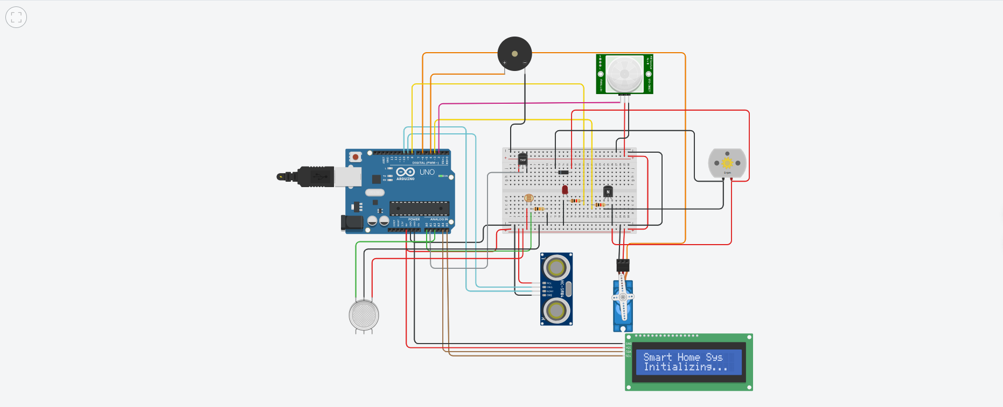
Fig 4.1: Complete Circuit Assembly in Tinkercad

6. Circuit Design and Connections

6.1 Automatic Door Lock/Unlock (Ultrasonic Sensor + Servo)
An HC-SR04 ultrasonic distance sensor continuously measures the distance of any object/person approaching the door. When the measured distance falls within the defined threshold, the servo motor rotates to the unlocked position; otherwise, it returns to the locked position.
Component Pin | Arduino Pin
HC-SR04 VCC | 5V
HC-SR04 GND | GND
HC-SR04 Trig | D9
HC-SR04 Echo | D10
Servo Signal | D6
Servo VCC | 5V
Servo GND | GND

6.2 Automatic Fan Speed Control (LM35 + DC Motor)
An LM35 temperature sensor provides an analog voltage proportional to the ambient temperature. This is converted to degrees Celsius and used to switch the DC motor (fan) between OFF, MEDIUM, and FULL speed using PWM through an NPN transistor driver circuit, with a flyback diode protecting the circuit from back-EMF.
Component Pin | Arduino Pin
LM35 VCC | 5V
LM35 Vout | A1
LM35 GND | GND
Transistor Base (via 1kΩ) | D3 (PWM)
Transistor Emitter | GND
Transistor Collector | Motor (–) terminal
Motor (+) terminal | 5V
Diode (flyback, parallel to motor) | Cathode–5V, Anode–Collector

6.3 Automatic Light Control (LDR + LED)
A photoresistor (LDR) forms a voltage divider with a 10kΩ resistor. As ambient light decreases, the LDR's resistance increases, lowering the voltage sensed at the analog pin. When this value drops below a defined threshold, the LED (representing the room light) is switched ON automatically.
Component Pin | Arduino Pin
LDR Leg 1 | 5V (via divider)
LDR Leg 2 / 10kΩ junction | A0
10kΩ Resistor (other leg) | GND
LED Anode (through 220Ω) | D8
LED Cathode | GND

6.4 16x2 I2C LCD Display
A PCF8574-based I2C LCD module displays real-time sensor readings and status for all sub-systems, cycling through multiple screens with a short delay between each.
Component Pin | Arduino Pin
LCD I2C GND | GND
LCD I2C VCC | 5V
LCD I2C SDA | A4
LCD I2C SCL | A5

6.5 PIR Motion Sensor + Buzzer (Secret Locker Alert)
A PIR sensor is mounted near a secret locker door. When motion is detected, the shared piezo buzzer sounds a single beep as an immediate audible alert, and the LCD/Serial Monitor display 'DETECTED! ALARM'.
Component Pin | Arduino Pin
PIR VCC | 5V
PIR GND | GND
PIR OUT | D2
Buzzer (+) | D4
Buzzer (–) | GND

6.6 Gas Sensor (MQ2) + Buzzer (Gas Leak Alert)
An MQ2 gas sensor continuously monitors the surrounding air quality. If the analog reading exceeds the calibrated safe threshold, the system interprets this as a gas leak and sounds the shared buzzer with a distinct two-beep pattern, differentiating it from the single-beep PIR alert.
Component Pin | Arduino Pin
MQ2 Gas Sensor VCC | 5V
MQ2 Gas Sensor GND | GND
MQ2 Gas Sensor AO | A2

7. Schematic Diagram
The complete schematic representation of the circuit, showing all component interconnections, is shown below:
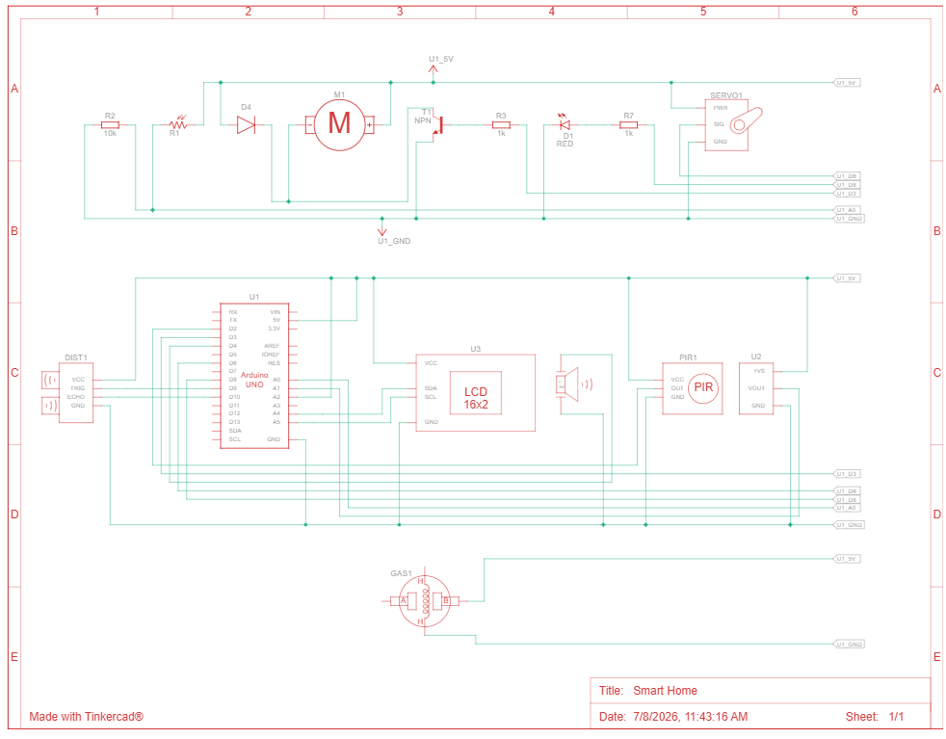
Fig 6.1: Full System Schematic Diagram

8. Working Principle / Logic Summary

8.1 Door Lock Logic
The door locking mechanism operates on a simple proximity-based decision rule governed by the ultrasonic distance sensor mounted at the main entrance. The sensor continuously emits ultrasonic pulses and measures the time taken for the echo to return, which is converted into a distance value in centimeters. This system evaluates two distinct cases in every cycle. In the first case, when the measured distance is less than or equal to the defined threshold of 50 cm — meaning a person or object has approached close enough to the door — the servo motor immediately rotates to the 90-degree position, physically representing the UNLOCKED state, and this status is reflected on both the LCD and Serial Monitor. In the second case, when the measured distance exceeds the 50 cm threshold — indicating that no one is currently near the door — the servo motor returns to its 0-degree resting position, representing the LOCKED state. This ensures the door remains secured by default and only opens when someone is genuinely present at close range, preventing accidental or unnecessary unlocking.

8.2 Fan Speed Logic (3 Conditions)
The fan speed control sub-system continuously reads the ambient temperature through the LM35 sensor and adjusts the DC motor's PWM output accordingly, resulting in three distinct operating cases. In the first case, when the sensed temperature is below 23°C, the room is considered comfortably cool, and the fan is kept completely OFF by setting the PWM value to 0, conserving energy when cooling is not required. In the second case, when the temperature lies between 23°C and 33°C, the system considers this a moderately warm condition and drives the fan at a MEDIUM speed with a PWM value of 128, providing gentle air circulation without consuming excessive power. In the third case, when the temperature reaches or exceeds 33°C, the room is considered hot, and the fan is switched to FULL speed with a PWM value of 255 to maximize cooling and maintain comfort. This three-tier response allows the fan to automatically scale its output in proportion to the actual thermal conditions of the room, rather than operating in a simple binary ON/OFF manner.

8.3 Light Control Logic
Automatic lighting is governed by the LDR sensor, which forms a voltage divider with a fixed 10kΩ resistor and produces an analog reading that varies inversely with the ambient light level — the darker the surroundings, the lower the sensed voltage. Two cases are evaluated continuously. In the first case, when the LDR reading falls below the threshold value of 500, the system interprets this as insufficient natural or artificial light in the room and automatically switches the LED (representing the room light) ON, ensuring the space remains illuminated without requiring manual intervention. In the second case, when the LDR reading is at or above the 500 threshold, indicating adequately bright conditions, the system keeps the LED OFF, avoiding unnecessary power consumption during daylight hours or in already well-lit environments. This closed-loop behavior means the light continuously adapts to real-time changes in brightness rather than relying on a fixed schedule.

8.4 Security Alert Logic (PIR and Gas Sensor)
The security and safety alert system relies on two independent sensors — the PIR motion sensor at the secret locker and the MQ2 gas sensor in the kitchen — both of which share the same buzzer but are distinguished by different beep patterns, giving rise to three distinct operating cases. In the first case, when the PIR sensor detects motion near the secret locker door, the system immediately sounds a single short beep on the buzzer, alerting residents to potential unauthorized access to the restricted locker area; this is also reflected on the LCD as 'DETECTED! ALARM'. In the second case, when the MQ2 gas sensor's analog reading exceeds its calibrated safety threshold, the system interprets this as a gas leak in the kitchen and sounds a distinctly different two-beep pattern on the same buzzer, allowing residents to immediately recognize — purely from the sound pattern — that the alert relates to a gas hazard rather than a security intrusion, without needing to look at the display. In the third case, when neither motion nor a gas leak is detected, the buzzer is explicitly and continuously held in the OFF (LOW) state, ensuring there is no ambiguity or residual sound from a previous alert cycle. This dual-sensor, dual-pattern approach allows a single shared buzzer to meaningfully communicate two entirely different categories of alerts.

9. Simulation Results (Tinker CAD)
The following screenshots demonstrate the working of each sub-system during simulation in Tinker CAD.

9.1 Door Lock/Unlock Operation
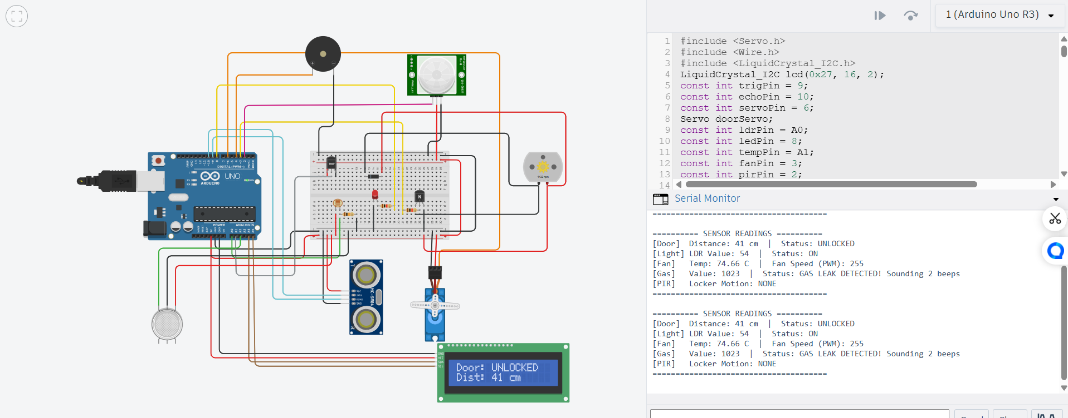
Fig 9.1: Door status UNLOCKED when object detected within range

9.2 Automatic Light Operation
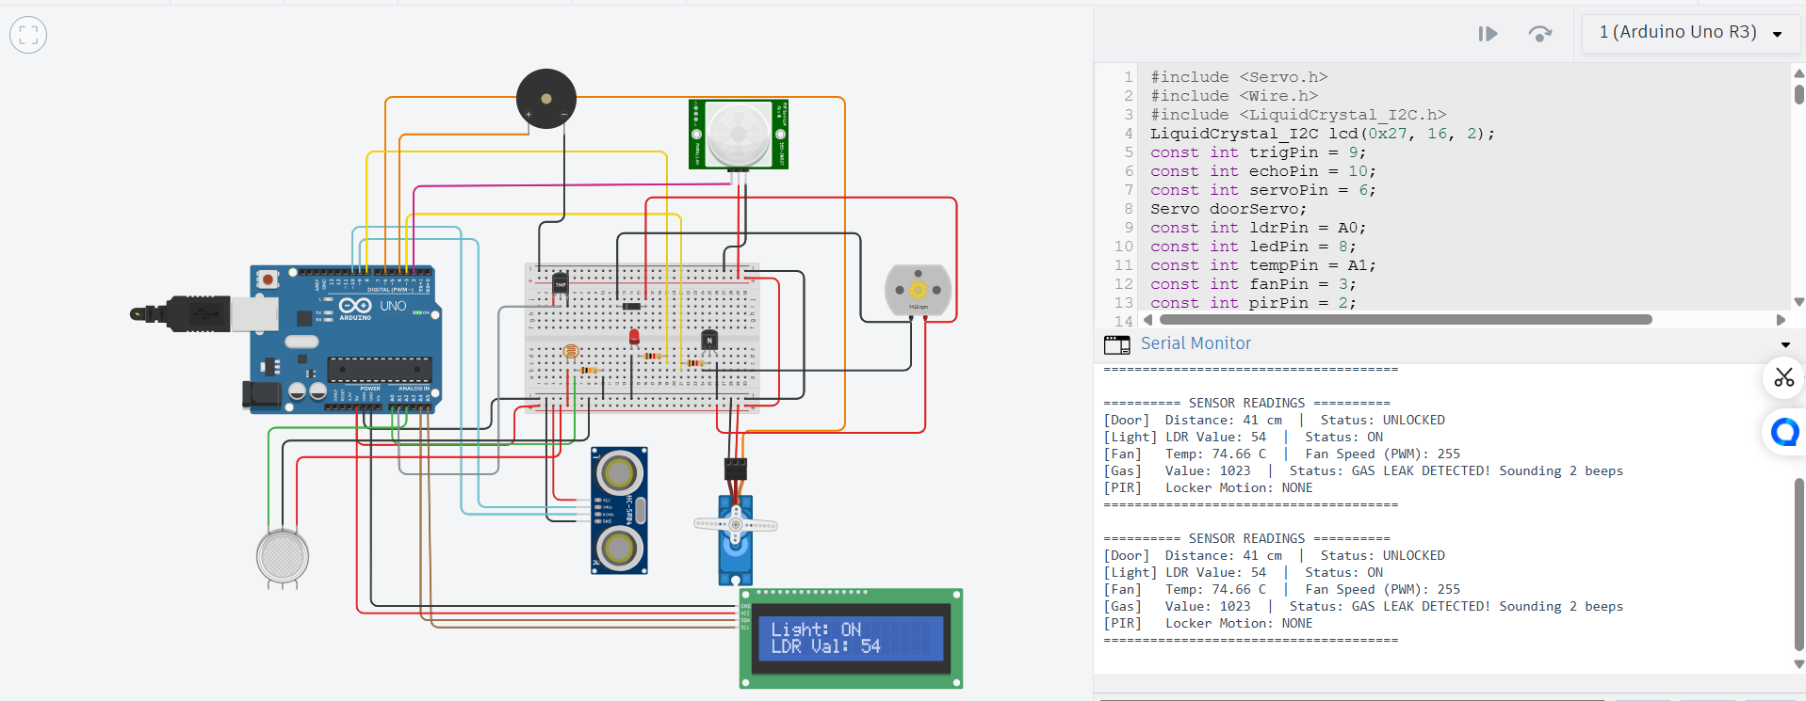
Fig 9.2: Light turns ON automatically under low ambient light

9.3 Automatic Fan Speed Operation
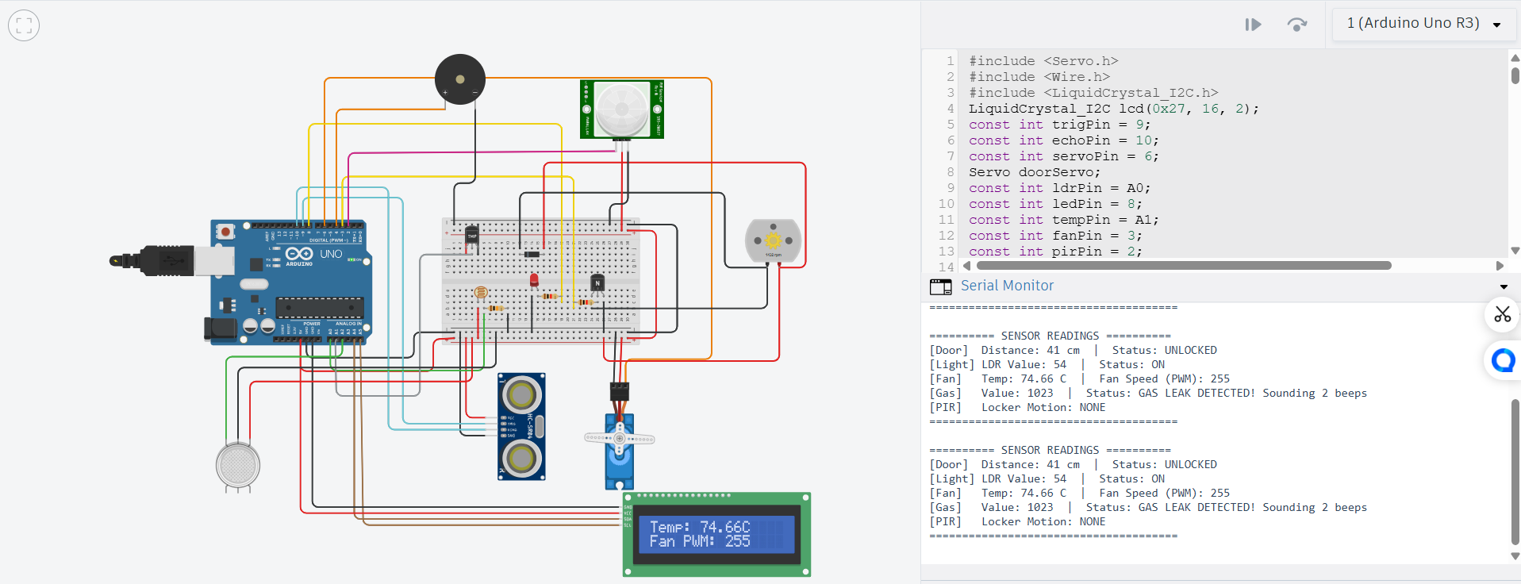
Fig 9.3: Fan speed (PWM) increasing with rising temperature

9.4 Gas Leak Detection Operation
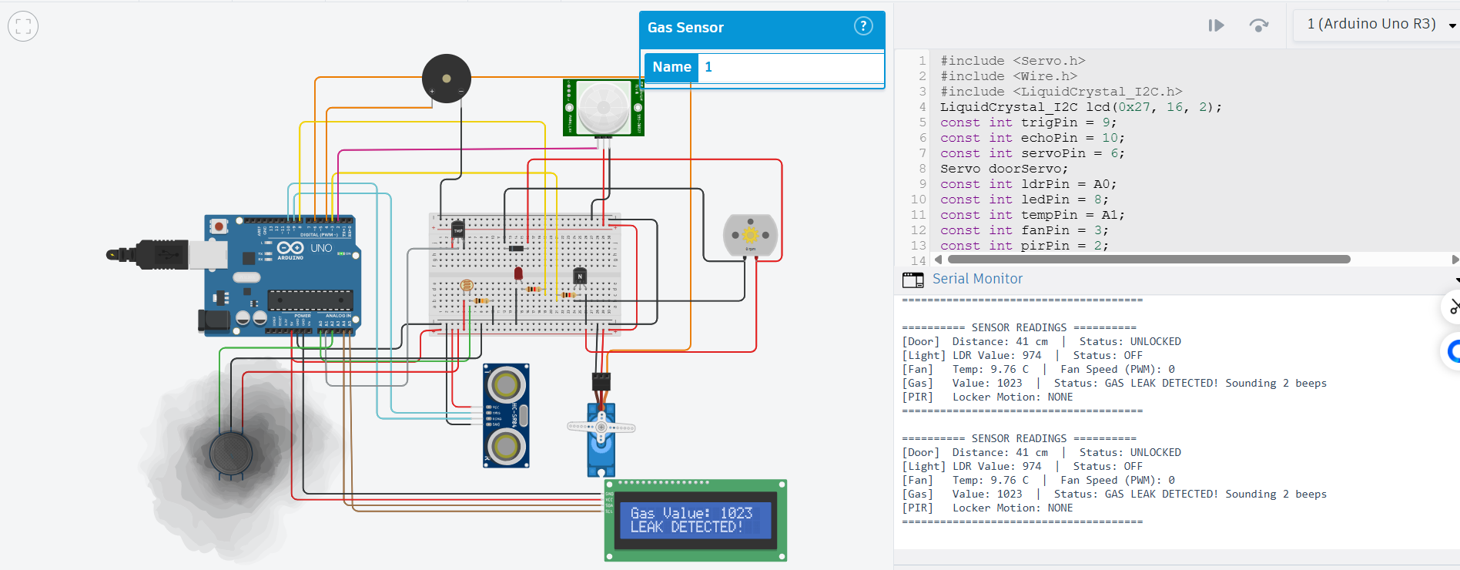
Fig 9.4: Gas leak detected — buzzer sounds 2-beep alert

9.5 Secret Locker Motion Detection Operation
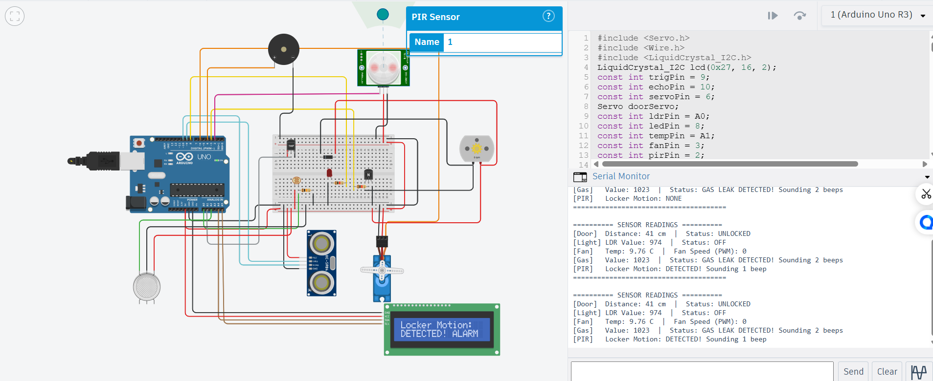
Fig 9.5: PIR motion detected near locker — buzzer sounds 1-beep alert

10. Conclusion
The Arduino Based Smart Home System successfully demonstrates the integration of multiple automation and safety sub-systems into a single, cohesive design. The door lock automatically responds to proximity, the fan speed adapts dynamically to ambient temperature, and the room light activates automatically in low-light conditions — reducing manual intervention and improving energy efficiency. The addition of PIR-based locker security and MQ2-based gas leak detection extends the system's utility beyond convenience into safety-critical monitoring, with distinct audible alert patterns allowing users to immediately identify the type of alert without needing to check a display. The use of a shared 16x2 I2C LCD and Serial Monitor output for all readings ensures the system remains transparent and easy to debug and calibrate. Overall, the project validates that a single low-cost microcontroller platform can effectively manage several independent smart-home functions simultaneously.

11. Future Scope
- Integration with a mobile application or IoT platform (e.g., Blynk, ThingSpeak) for remote monitoring and control.
- Addition of a keypad or RFID-based authentication for the door lock instead of simple proximity detection.
- Use of a more precise temperature/humidity sensor (e.g., DHT22) for improved fan control accuracy.
- Data logging of gas and motion events with timestamps for historical security analysis.
- Migration from simulation to a physical hardware prototype for real-world deployment and testing.

